**DASC - 5300 : FOUNDATION OF COMPUTING DATABASE PROJECT**

**NIVAS MARUDHAVANAN - (1002197280)**

**JENNITHRA SRINIVASAN - (1002206950)**

**SPRING 2024**

**DR. SOUMAYA GHARSALLAOUI**

**MAY 07, 2024**



**DEPARTMENT OF DATASCIENCE**

**HONOR CODE**

I pledge, on my honor, to upload UT Arlington’s tradition of academic integrity, a tradition that values hard work and honest effort in the pursuit of academic excellence.

I promise that I will submit only work that I personally create or that I contribute to group collaborations, and I will appropriately reference any work from other source. I will follow the highest standards of integrity and uphold the spirit of the honor code.

**DATABASE CREATION:**

def get_sqlite_datatype(python_dtype):

if python_dtype == int:

return "INTEGER"

elif python_dtype == float:

return "REAL"

else:

return "TEXT"

def get_column_datatypes(file_path):

with open(file_path, 'r', newline='') as file:

reader = csv.reader(file)

sample_row = next(reader)

column_datatypes = []

for col_val in next(reader):

if col_val.isdigit():

column_datatypes.append(int)

else:

try:

float(col_val)

column_datatypes.append(float)

except ValueError:

column_datatypes.append(str)

sqlite_datatypes = [get_sqlite_datatype(dtype) for dtype in column_datatypes]

return sqlite_datatypes

def create_table_with_datatypes(table_name, column_names, column_datatypes):

columns = ", ".join(f"\"{name}\" {dtype}" for name, dtype in zip(column_names, column_datatypes))

create_statement = f"CREATE TABLE IF NOT EXISTS {table_name} ({columns})"

conn = sqlite3.connect(db_name)

cursor = conn.cursor()

cursor.execute(create_statement)

conn.commit()

conn.close()

def insert_data(table_name, data):

conn = sqlite3.connect(db_name)

cursor = conn.cursor()

placeholders = ", ".join("?" for _ in data)

insert_statement = f"INSERT INTO {table_name} VALUES ({placeholders})"

cursor.execute(insert_statement, data)

conn.commit()

conn.close()

def table_creation_insertion():

for file_name in file_list:

table_name = file_name.split('.')[0]

column_datatypes = get_column_datatypes(file_location + file_name)

with open(file_location + file_name, 'r', newline='') as file:

reader = csv.reader(file)

column_names = next(reader)

column_names = [name.strip('\ufeff').strip() for name, dtype in zip(column_names, column_datatypes)]

create_table_with_datatypes(table_name, column_names, column_datatypes)

for row in reader:

insert_data(table_name, row)

def get_sqlite_datatype(python_dtype):

if python_dtype == int:

return "INTEGER"

elif python_dtype == float:

return "REAL"

else:

return "TEXT"

def get_column_datatypes(file_path):

with open(file_path, 'r', newline='') as file:

reader = csv.reader(file)

sample_row = next(reader)

column_datatypes = []

for col_val in next(reader):

if col_val.isdigit():

column_datatypes.append(int)

else:

try:

float(col_val)

column_datatypes.append(float)

except ValueError:

column_datatypes.append(str)

sqlite_datatypes = [get_sqlite_datatype(dtype) for dtype in column_datatypes]

return sqlite_datatypes

def create_table_with_datatypes(table_name, column_names, column_datatypes):

columns = ", ".join(f"\"{name}\" {dtype}" for name, dtype in zip(column_names, column_datatypes))

create_statement = f"CREATE TABLE IF NOT EXISTS {table_name} ({columns})"

conn = sqlite3.connect(db_name)

cursor = conn.cursor()

cursor.execute(create_statement)

conn.commit()

conn.close()

def insert_data(table_name, data):

conn = sqlite3.connect(db_name)

cursor = conn.cursor()

placeholders = ", ".join("?" for _ in data)

insert_statement = f"INSERT INTO {table_name} VALUES ({placeholders})"

cursor.execute(insert_statement, data)

conn.commit()

conn.close()

def table_creation_insertion():

for file_name in file_list:

table_name = file_name.split('.')[0]

column_datatypes = get_column_datatypes(file_location + file_name)

with open(file_location + file_name, 'r', newline='') as file:

reader = csv.reader(file)

column_names = next(reader)

column_names = [name.strip('\ufeff').strip() for name, dtype in zip(column_names, column_datatypes)]

create_table_with_datatypes(table_name, column_names, column_datatypes)

for row in reader:

insert_data(table_name, row)

This Python script is designed to facilitate the transformation of CSV data into SQLite database tables. It starts by defining functions to determine the appropriate SQLite data types for the columns based on the types of data present in the CSV files. The get_column_datatypes() function reads a sample of data from the CSV file to infer the data types of each column, such as integers, floats, or strings. These inferred data types are then converted to SQLite-compatible types using the get_sqlite_datatype() function.

Once the data types are determined, the script proceeds to create SQLite tables with the correct column names and data types using the create_table_with_datatypes() function. For each CSV file provided, the script iterates through the rows, inserting the data into the corresponding SQLite table with the insert_data() function.

Overall, this script automates the process of creating SQLite database tables from CSV files, ensuring data integrity and compatibility between the two formats. It's a handy tool for managing and analyzing data stored in CSV files within an SQLite database environment.

**UI INITIALIZATION:**

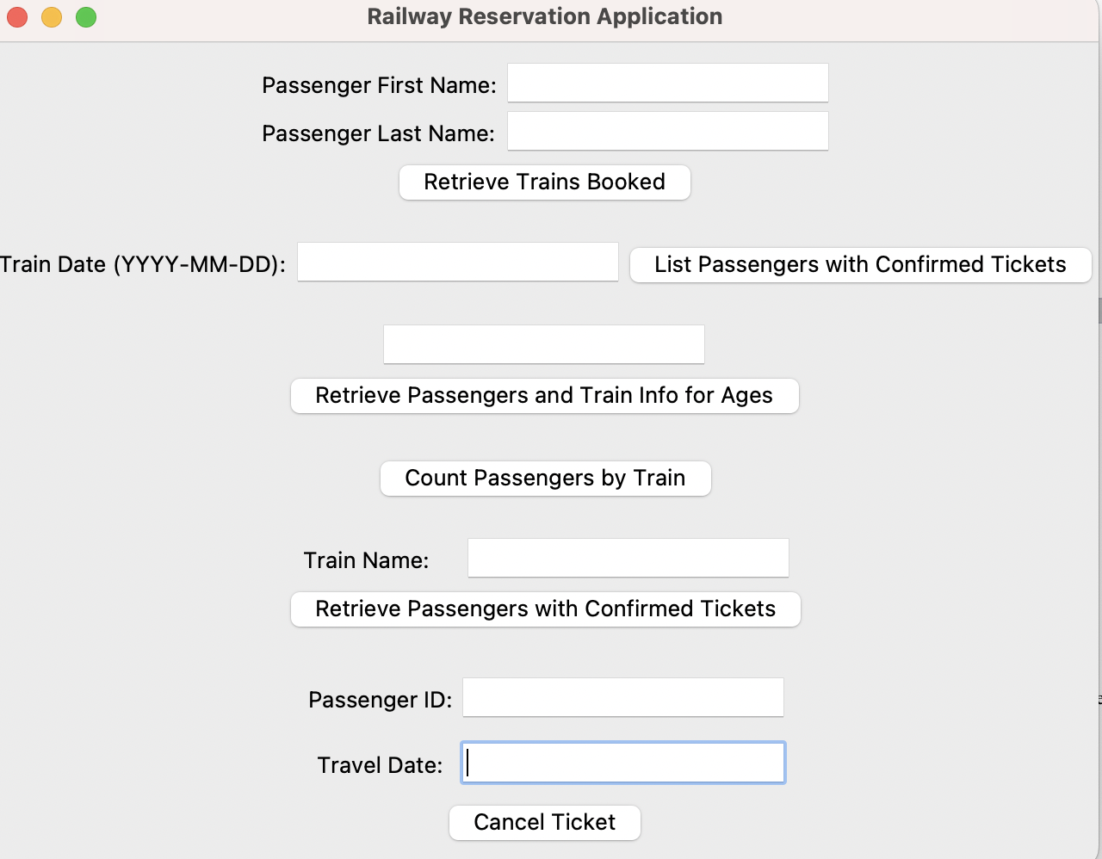

**# Create main window**

root = tk.Tk()

root.title("Railway Reservation Application")

This code snippet creates the primary window for a Railway Reservation Application using Tkinter, a Python GUI toolkit. The tk.Tk() method call generates the main window instance, and root.title() changes the window's title to "Railway Reservation Application". This window will be the primary interface for users dealing with the reservation system.

**# Query 1:** Retrieve trains booked by passenger

frame_query_1 = tk.Frame(root)

frame_query_1.pack(pady=10)

label_first_name = tk.Label(frame_query_1, text="Passenger First Name:")

label_first_name.grid(row=0, column=0)

entry_first_name = tk.Entry(frame_query_1)

entry_first_name.grid(row=0, column=1)

label_last_name = tk.Label(frame_query_1, text="Passenger Last Name:")

label_last_name.grid(row=1, column=0)

entry_last_name = tk.Entry(frame_query_1)

entry_last_name.grid(row=1, column=1)

button_query_1 = tk.Button(frame_query_1, text="Retrieve Trains Booked", command=query_1)

button_query_1.grid(row=2, column=0, columnspan=2)

This code sample creates a part within the main window interface of a Railway Reservation Application, allowing users to obtain trains reserved by a passenger. It has input sections for the passenger's first and last names, as well as a button labeled "Retrieve Trains Booked". When you click the button, it calls a function (query_1) that queries the database and displays the results.

**# Query 2:** List passengers with confirmed tickets on a specific date

frame_query_2 = tk.Frame(root)

frame_query_2.pack(pady=10)

label_train_date = tk.Label(frame_query_2, text="Train Date (YYYY-MM-DD):")

label_train_date.grid(row=0, column=0)

entry_train_date = tk.Entry(frame_query_2)

entry_train_date.grid(row=0, column=1)

button_query_2 = tk.Button(frame_query_2, text="List Passengers with Confirmed Tickets", command=query_2)

button_query_2.grid(row=0, column=2)

This portion of code adds a user interface component within the Railway Reservation Application's main window for querying passengers who have confirmed tickets for a certain date. It creates a frame (frame_query_2) with an entry field (entry_train_date) for entering the required date in the YYYY-MM-DD format. A label (label_train_date) specifies the input format. A button labeled "List Passengers with Confirmed Tickets" is also included, which when selected executes the query_2 function, which is expected to handle the retrieval of passenger information depending on the specified date.

**# Query 3:** Retrieve passengers and train information for ages 50 to 60

frame_query_3 = tk.Frame(root)

frame_query_3.pack(pady=10)

button_query_3 = tk.Button(frame_query_3, text="Retrieve Passengers and Train Info for Ages 50-60", command=query_3)

button_query_3.pack()

This code snippet adds a part to the Railway Reservation Application's main window interface for performing Query 3, which retrieves information about passengers aged 50 to 60, as well as their train data. It generates a frame (frame_query_3) to organize the UI elements, which includes a button labeled "Retrieve Passengers and Train Info for Ages 50-60". Clicking this button invokes the query_3 function, which is expected to retrieve and show relevant passenger and train information for the chosen age range.

**# Query 4:** Count passengers by train

frame_query_4 = tk.Frame(root)

frame_query_4.pack(pady=10)

button_query_4 = tk.Button(frame_query_4, text="Count Passengers by Train", command=query_4)

button_query_4.pack()

This code segment adds a part to the Railway Reservation Application's main window interface for performing Query 4, which seeks to count the number of passengers per train. It creates a frame (frame_query_4) to organize the interface components and has a button named "Count Passengers by Train". Clicking this button invokes the query_4 function, which is meant to calculate and display the passenger count for each train.

**# Query 5:** Retrieve passengers with confirmed tickets in a train

frame_query_5 = tk.Frame(root)

frame_query_5.pack(pady=10)

label_train_name = tk.Label(frame_query_5, text="Train Name:")

label_train_name.grid(row=0, column=0)

entry_train_name = tk.Entry(frame_query_5)

entry_train_name.grid(row=0, column=1)

button_query_5 = tk.Button(frame_query_5, text="Retrieve Passengers with Confirmed Tickets", command=query_5)

button_query_5.grid(row=1, column=0, columnspan=2)

This code creates a part in the main window interface of the Railway Reservation Application for Query 5, which involves obtaining people who have confirmed tickets for a given train. It generates a frame (frame_query_5) to organize the interface elements, which include an entry field (entry_train_name) for entering the train name and a button labeled "Retrieve Passengers with Confirmed Tickets" to invoke the query_5 function, which retrieves and displays the relevant passenger information.

**# Query 6**: Cancel ticket

frame_query_6 = tk.Frame(root)

frame_query_6.pack(pady=10)

passenger_id_label = tk.Label(frame_query_6, text="Passenger ID:")

passenger_id_label.grid(row=0, column=0, pady=5)

passenger_id_entry = tk.Entry(frame_query_6)

passenger_id_entry.grid(row=0, column=1, pady=5)

travel_date_label = tk.Label(frame_query_6, text="Travel Date:")

travel_date_label.grid(row=1, column=0, pady=5)

travel_date_entry = tk.Entry(frame_query_6)

travel_date_entry.grid(row=1, column=1, pady=5)

cancel_button = tk.Button(frame_query_6, text="Cancel Ticket", command=cancel_ticket)

cancel_button.grid(row=2, column=0, columnspan=2)

root.mainloop()

This code adds a user interface component to the main window of the Railway Reservation Application for Query 6, which includes canceling a ticket. It constructs a frame (frame_query_6) to organize the interface elements, which include entry fields (passenger_id_entry and travel_date_entry) for entering the passenger ID and travel date, respectively. To ensure clarity, labels (passenger_id_label and travel_date_label) are provided. When the "Cancel Ticket" button is pressed, it executes the cancel_ticket function, allowing users to cancel the ticket for the selected passenger and travel date. Finally, the root.mainloop() function is invoked to initiate the event loop and allow user interaction with the application's graphical interface.

**QUERY 1:**

def query_1():

passenger_first_name = entry_first_name.get()

passenger_last_name = entry_last_name.get()

query = "SELECT Train.\"Train Name\" FROM Train JOIN Booked ON Passenger.SSN = Booked.Passanger_ssn JOIN Passenger ON Booked.Train_Number = Train.\"Train Number\" WHERE Passenger.first_name=? AND Passenger.last_name=?"

result = execute_query(query, (passenger_first_name, passenger_last_name))

messagebox.showinfo("Trains Booked", "The user is booked on the following trains: \n" + "\n".join(str(row[0]) for row in result))

**QUERY 2:**

def query_2():

train_date = entry_train_date.get()

query = "SELECT DISTINCT Passenger.first_name, Passenger.last_name\

FROM Passenger JOIN Booked ON Passenger.SSN = Booked.Passanger_ssn \

JOIN Train ON Booked.Train_Number = Train.\"Train Number\"\

JOIN Train_Status ON Train.\"Train Name\" = Train_Status.TrainName\

WHERE Train_Status.TrainDate = ? \

AND Booked.Staus = 'Booked'"

print(query)

result = execute_query(query, (train_date,))

print(result)

messagebox.showinfo("Passengers with Confirmed Tickets", "Passengers with confirmed tickets on the entered date: \n" + "\n".join([f"{row[0]} {row[1]}" for row in result]))

**QUERY 3:**

def query_3():

age_range = int(entry_age.get())  
 start = age_range - (age_range % 10)  
 end = start+10  
 current_year = datetime.now().year  
 start_year = current_year - start  
 end_year = current_year - end  
 l ast_two_start = str(start_year)[-2:]  
 last_two_end = str(end_year)[-2:]  
 query = f"""  
 SELECT   
 t."Train Number",   
 t."Train Name",   
 t."Source Station",   
 t."Destination Station",   
 p.first_name,   
 p.last_name,   
 p.address,   
 b.Ticket_Type,   
 b.Staus  
 FROM   
 Passenger p   
 JOIN Booked b ON p.SSN = b.Passanger_ssn   
 JOIN Train t ON b.Train_Number = t."Train Number"  
 WHERE   
 CAST(substr(p.bdate, -2) AS INTEGER) BETWEEN {last_two_end} AND {last_two_start}  
 """  
 print(query)  
 result = execute_query(query)

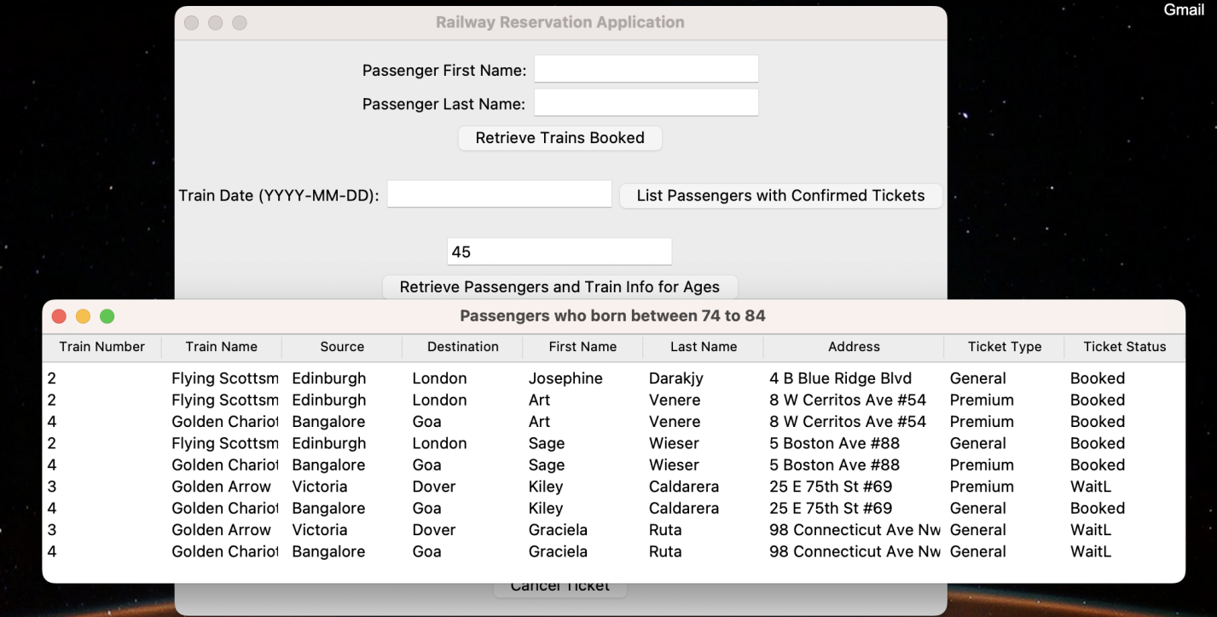

**QUERY 4:**

def query_4():

query = "SELECT Train.\"Train Name\" , COUNT(*) FROM Booked JOIN Train ON Booked.Train_Number = Train.\"Train Number\" GROUP BY Train.\"Train Name\""

result = execute_query(query)

messagebox.showinfo("Passenger Count by Train", "Passenger count by Train Name: \n" + "\n".join([f"{row[0]}: {row[1]} passengers" for row in result])

**QUERY 5:**

def query_5():

train_name = entry_train_name.get()

query = "SELECT Passenger.first_name, Passenger.last_name FROM Booked JOIN Passenger ON Booked.Passanger_ssn = Passenger.SSN WHERE Booked.Train_Number=(SELECT \"Train Number\" FROM Train WHERE \"Train Name\"=?) AND Booked.Staus='Booked'"

result = execute_query(query, (" "+train_name,))

messagebox.showinfo("Passengers with Confirmed Tickets in a Train", "Passengers with confirmed tickets in the entered train: \n" + "\n".join([f"{row[0]} {row[1]}" for row in result])

**QUERY 6:**

def cancel_ticket():  
 passenger_id = passenger_id_entry.get()  
 travel_date = travel_date_entry.get()  
 try:  
 output_show = f"""SELECT Passanger_ssn   
 FROM booked   
 WHERE Ticket_Type = (  
 SELECT Ticket_Type   
 FROM booked   
 WHERE Passanger_ssn = {passenger_id})   
 AND Train_Number = (  
 SELECT Train_Number   
 FROM booked   
 WHERE Passanger_ssn = {passenger_id})   
 AND Staus = 'WaitL'   
 LIMIT 1 """  
 result_show = execute_query(output_show)  
 query = f"""  
 UPDATE Booked  
 SET Staus = 'Booked'  
 WHERE Passanger_ssn = (  
 SELECT Passanger_ssn  
 FROM Booked  
 WHERE Ticket_Type = (  
 SELECT Ticket_Type  
 FROM Booked  
 WHERE Passanger_ssn = {passenger_id}  
 )  
 AND Train_Number = (  
 SELECT Train_Number  
 FROM Booked  
 WHERE Passanger_ssn = {passenger_id}  
 )  
 AND Staus = 'WaitL'  
 AND EXISTS (  
 SELECT 1  
 FROM Train_Status ts  
 JOIN Train t ON TRIM(t."Train Name") = TRIM(ts.TrainName)  
 WHERE ts.TrainDate = '{travel_date}'  
 AND t."Train Number" = (SELECT Train_Number FROM Booked WHERE Passanger_ssn = '{passenger_id}')  
 AND (ts.PremiumSeatsAvailable > 0 OR ts.GenSeatsAvailable > 0)  
 )  
 LIMIT 1  
 );  
 """  
 query_delete = f"""DELETE FROM Booked WHERE Passanger_ssn = {passenger_id}"""  
 print(query)  
 execute_query(query)  
 execute_query(query_delete)  
 print(result_show)  
 if result_show:  
 messagebox.showinfo("Passenger SSN gets", f"Passenger SSN: {result_show[0][0]} Ticket gets confirmed and {passenger_id} Ticket gets Cancelled")  
 else:  
 messagebox.showinfo("No Result", "No result found.")  
  
 except sqlite3.Error as e:  
 messagebox.showerror("Database Error", f"An error occurred: {str(e)}")

**TABLE BEFORE UPDATING:**

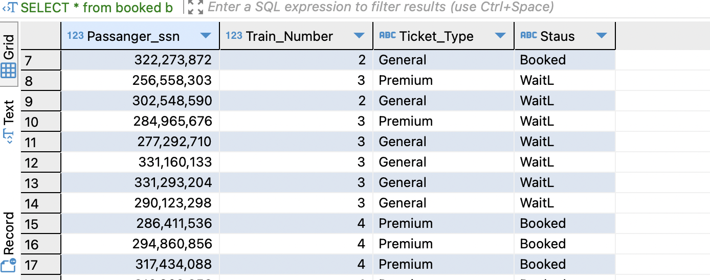

**UI UPDATE:**

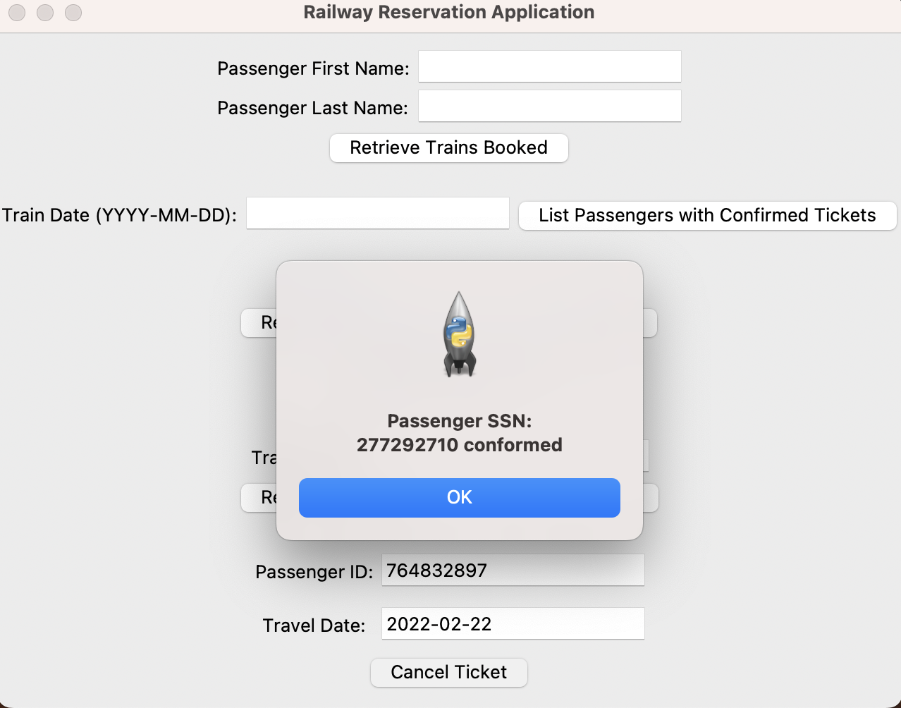

**AFTER UPDATE:**

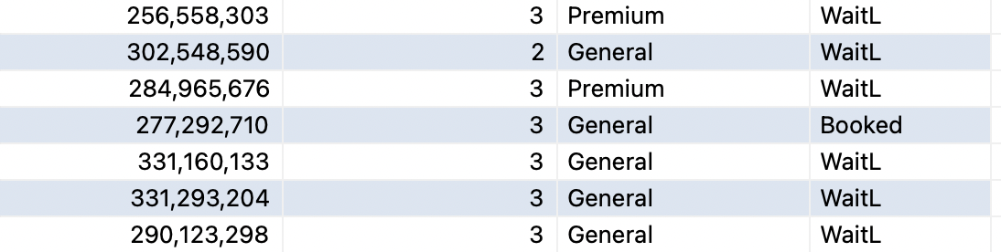

**TEAM CONTRIBUTION:**

**IMPORTING THE DATA TO SQLITE3**: NIVAS MARUDHAVANAN

**CONNECTING GUI TO SQL**: NIVAS MARUDHAVANAN, JENNITHRA SRINIVASAN

**BUILDING GUI**: NIVAS MARUDHAVANAN, JENNITHRA SRINIVASAN

**DEVELOPING REQUIRED QUERIES**: NIVAS MARUDHAVANAN, JENNITHRA SRINIVASAN

**DOCUMENTATION**: JENNITHRA SRINIVASAN